1. Create a lambda function
On your AWS Management Console go to Lambda:
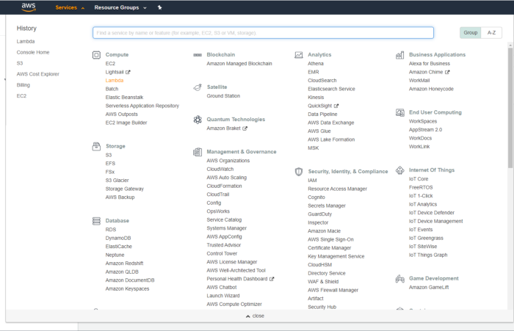
Create a new function:
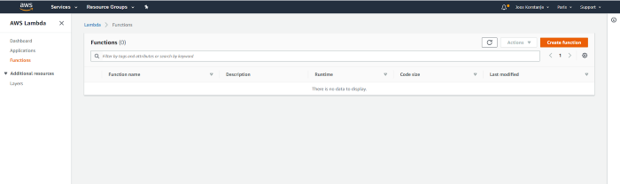
Choose “author from scratch” and give your function a name. In this case, the api will generate secure passwords.
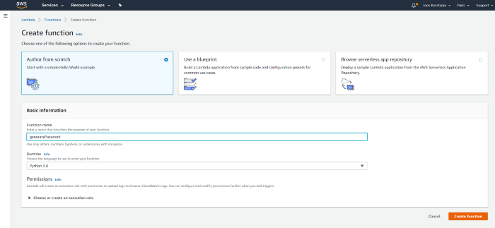

2. Write the lambda function
In your newly created lambda function, go to Function Code:
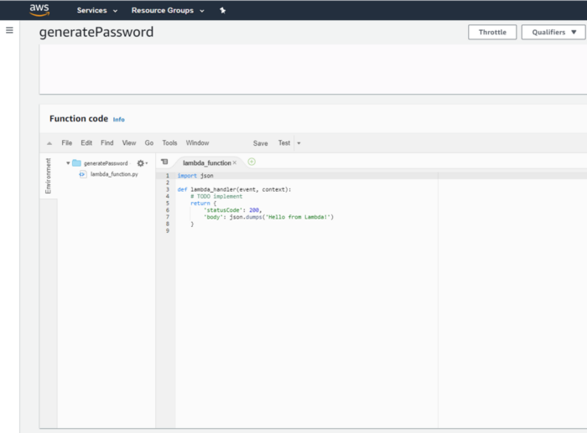
And write your function:
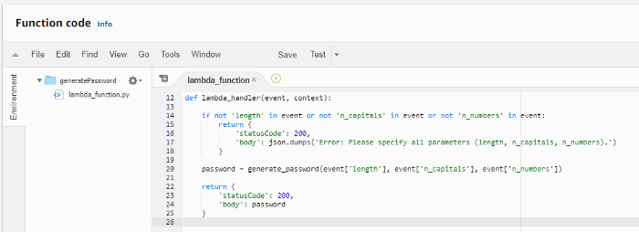
The code I use is the following:

3. Configure a test
Go to the test menu and click on configure tests.
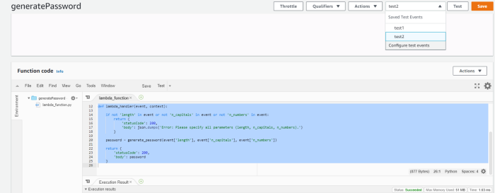
Click on create new test event and specify the input for your test in the dictionary before clicking create:
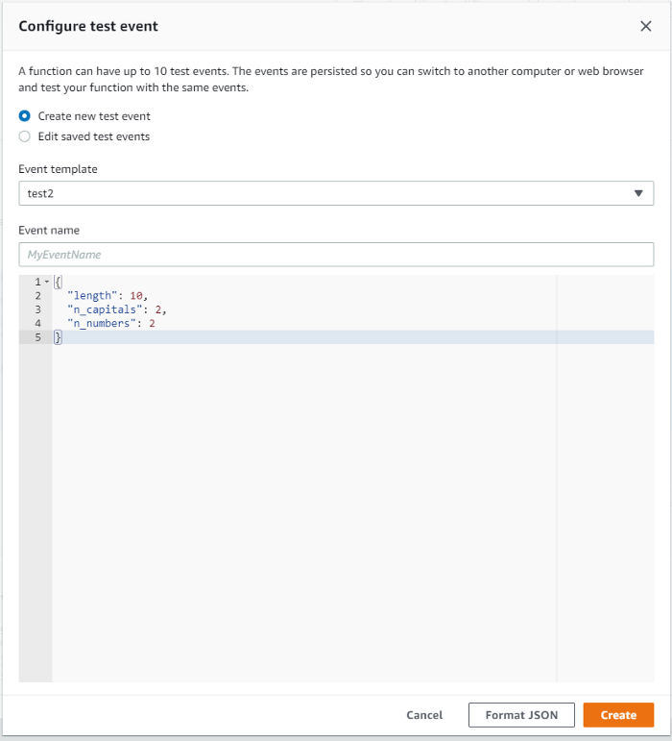
Test your Lambda function by clicking on Test:
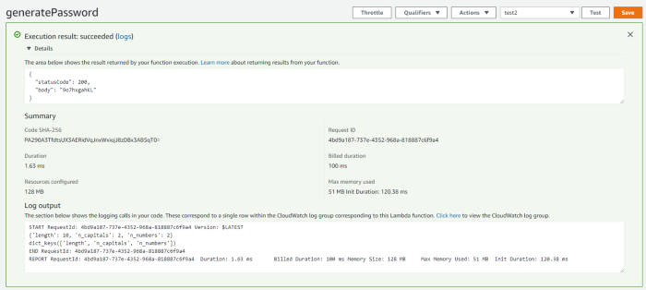
You see that it sent back a password in the ‘body’ of the dictionary (or the json).

4. Build the API Gateway
Go to API Gateway through the AWS Management Console. Click on REST API.
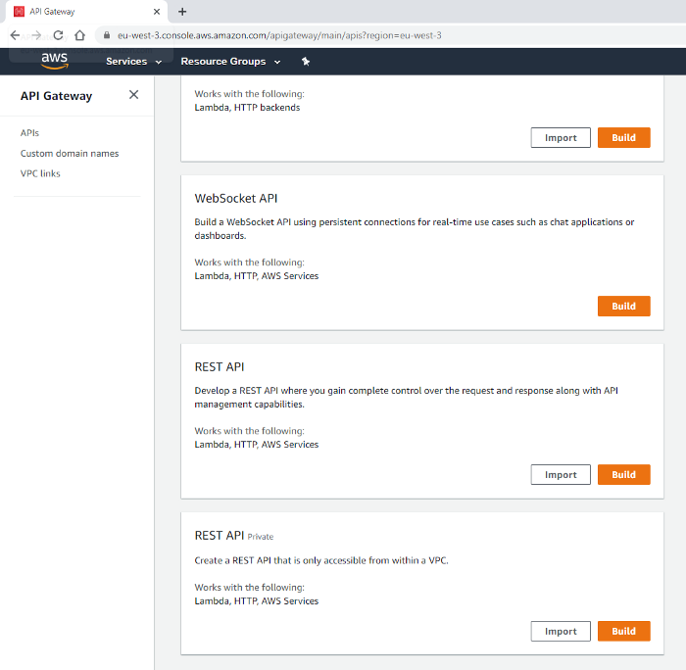
Click on New API and choose a name:
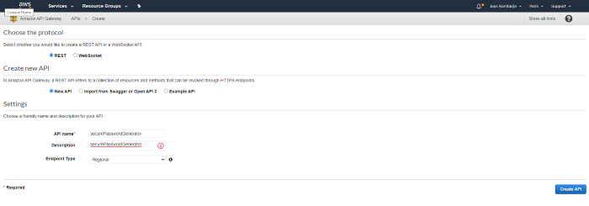
Create a POST method and choose the integration type “Lambda Function”. Then select the name of your Lambda Function.
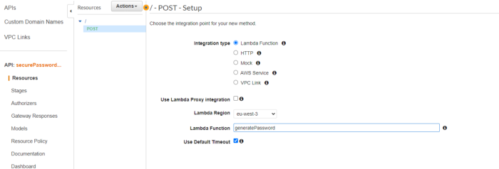
You should now see this:
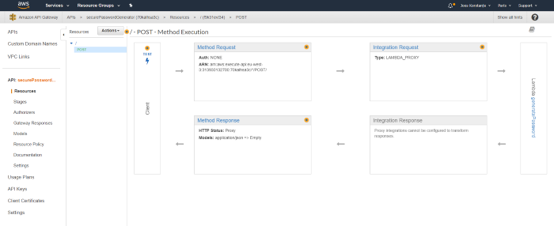
As a final step, deploy your API:
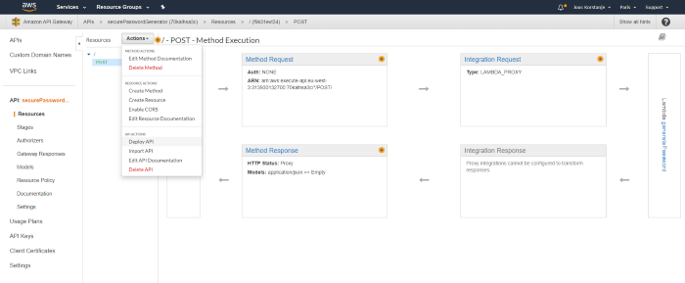
You can name it “prod” for example:
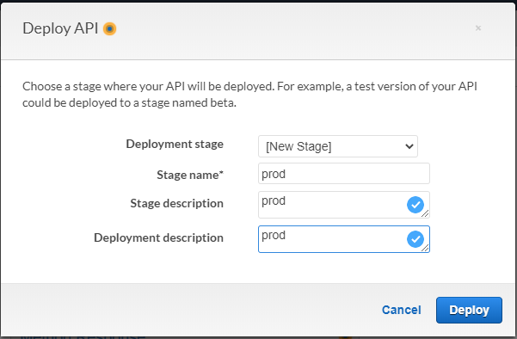
The API Gateway should now tell you the URL to find your API:
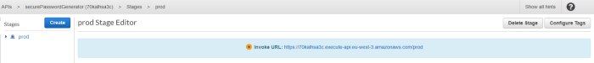

5. Test Your API for real
You can now use a Python Notebook, or anything of your liking, to test out your API.
If you copy-paste this in a notebook, the API will send you a new password!

CODE of Password Generator:
import json
import random
import string

def lambda_handler(event, context):
if not 'length' in event or not 'n_capitals' in event or not 'n_numbers' in event:
return {
'statusCode': 200,
'body': json.dumps('Error: Specify all params')
}

password = generate_password(event['length'], event['n_capitals'], event['n_numbers'])

return {
'statusCode': 200,
'body': password
}

def generate_password(length, n_capitals, n_numbers):
if n_capitals + n_numbers > length:
return "Error: The sum of n_capitals and n_numbers should not exceed the password length."

num_lower = length - (n_capitals + n_numbers)

lowercase_letters = string.ascii_lowercase
uppercase_letters = string.ascii_uppercase
digits = string.digits

password_list = []

for _ in range(n_capitals):
password_list.append(random.choice(uppercase_letters))
for _ in range(n_numbers):
password_list.append(random.choice(digits))
for _ in range(num_lower):
password_list.append(random.choice(lowercase_letters))

random.shuffle(password_list)
password = ''.join(password_list)
return password

